Freshwater Improvement Scenario Builder for Lakes

WebApp User Guide

DATE

**Freshwater Improvement Scenario Builder for Lakes: WebApp User Guide**

**Version:**

**Date of issue:**

**Authors:** Olivier Ausseil, Traverse Environmental

Ton Snelder, LWP

Mike Kittridge, Headwaters Hydrology

Deniz Ozkundakci, University of Waikato

Laura Keenan, Traverse Environmental

For queries and further information please contact:

Olivier Ausseil, Traverse Environmental

olivier@traverse.co.nz



TABLE OF CONTENTS

1 Purpose 5

1.1 Purpose of this User Guide 5

1.2 Glossary of key terms 5

1.3 Overview of the Freshwater Improvement Scenario Builder for Lakes WebApp 6

1.4 Inputs and outputs 7

2 WebApp methodology 9

2.1 Indicators 9

2.2 Lakes and lake catchment delineation 9

2.3 Current state: monitored lakes 10

2.4 Current state: unmonitored lakes 11

2.5 Reference state 11

2.6 Modelling catchment management scenarios 12

2.6.1 Nutrient loss rates 12

2.6.2 Assigning nutrient loss rates to land areas 12

2.6.3 Default mitigation effectiveness for nutrients 14

2.6.4 Estimating total current nutrient loss 16

2.6.5 Estimating the total scenario nutrient loss 16

2.6.6 Predicting scenario indicator values for lakes 16

3 Examples of outputs for selected scenarios 17

3.1 Scenarios 17

3.2 Nutrients 17

4 User Guide 21

4.1 Using the WebApp to explore water quality current state 21

4.2 Using the WebApp to assess catchment scenarios 22

4.2.1 Land mitigation scenario 22

4.2.2 Land use change scenario 22

4.2.3 Exporting the results 22

4.3 Example 23

4.4 Troubleshooting 23

Acknowledgements 24

References 25

Appendix A: Land use types and loss rates 27

Appendix B: Estimated reference loads 30

5 Appendix C: Lake models 34

5.1 Reference state predictions 34

5.2 Scenario predictions 35

# Purpose

## Purpose of this User Guide

This User Guide provides background information and instructions for using the Freshwater Improvement Scenario Builder for Lakes web application (henceforth ‘Scenario Builder for Lakes WebApp’ or ‘WebApp’), which can be accessed at <https://www.monitoringfreshwater.co.nz/>. It gives a summary of the purpose of the Scenario Builder for Lakes WebApp, the underlying calculations, assumptions and limitations and a step-by-step user guide.

This document refers to the Freshwater Improvement Scenario Builder for Lakes WebApp version available as of 13 August 2024.

## Glossary of key terms

**Attribute:** a measurable characteristic of freshwater as defined by the National Policy Statement for Freshwater Management 2020 (NPS-FM). NPS-FM attributes are generally defined by more than one component (i.e., multiple statistics calculated from water quality observations). The Scenario Builder for Rivers WebApp only reports and models median values of the indicators and, therefore, does not report or model full attributes or Attribute States. However, for the indicators dissolved reactive phosphorus (DRP) and nitrate nitrogen (NO3-N), the Scenario Builder for Rivers WebApp displays the NPS-FM band thresholds for the median concentration component of the associated NPS-FM attributes.

**Contaminant:** a pollutant; the Scenario Builder for Rivers WebApp models three contaminants of fresh water in New Zealand – nitrogen, phosphorus and *E. coli*. ‘Contaminant loss’ refers to the process of contaminants being generated and transported from land to water, for example via overland flow or leaching processes.

**Improvement**: a change in an indicator to a better state, compared with a current (baseline) state. In the Scenario Builder for Rivers WebApp, improvements correspond to a reduction in the median concentration of nutrients or *E.coli* in rivers relative to the current state (i.e., the current median value). Conversely, an increase in the median values of the indicators is considered a degradation.

**Indicator**: physical, chemical, and biological properties of water that provide information about its suitability for various uses. The six indicators represented in the Scenario Builder for Rivers WebApp are total nitrogen (TN), total phosphorus (TP), nitrate nitrogen (NO3-N), dissolved reactive phosphorus (DRP), *E. coli* and periphyton. The nutrients and *E. coli* are referred to as ‘measured indicators’ in the WebApp – i.e., the WebApp accesses measurements of these indicators – while periphyton is a modelled/estimated indicator, as explained further in Section **Error! Reference source not found.**.

**Lag:** the time taken for a change in a contaminant discharge at the land surface to reach a corresponding equilibrium at a downstream measuring point or receiving water body.

**Mitigation effectiveness:** in the WebApp, mitigation effectiveness is expressed as a relative change (%) and corresponds to the degree of reduction in contaminant losses from land as a result of mitigation actions.

**River Environment Classification (REC)**: a classification system for rivers and streams based on factors that influence water quality and biology. The primary factors include climate, source of flow, geology and land cover.

**Digital river network:** a geospatial information layer describing the national drainage network including streams and rivers and their associated catchment areas. The Scenario Builder for Rivers WebApp uses version 2.5.

**Segment**: a defined length of river or stream channel represented by the digital network. In the Scenario Builder for Rivers WebApp, river segments are those used in the REC version 2.5.

## Overview of the Freshwater Improvement Scenario Builder for Lakes WebApp

The Freshwater Improvement Scenario Builder for Lakes web application (WebApp) allows the user to simulate on-land mitigations and land use changes in the catchment of lakes and predict the associated changes to key in-lake water quality indicators: nutrients (total nitrogen (TN) and total phosphorus (TP)), phytoplankton biomass and visual clarity (Secchi depth). These types of simulations are important technical information for developing policy in the context of managing lake water quality and implementation of the National Policy Statement for Freshwater Management (NPS-FM). The WebApp includes all North and South Island lakes for which the surface water catchments are reliably defined based on the New Zealand national digital drainage network (DN2.4) and includes both monitored and unmonitored lakes.

The expected audience and users include multi-party catchment groups or stakeholders (including farmers, iwi, NGOs, council catchment management staff), their advisors, and/or any of these parties individually. The Scenario Builder for Lakes WebApp has been designed to be a simple, freely and publicly available analysis system that enables end-users to explore mixes of land mitigations and land use changes for defined areas and predict the effect of these on lake water quality.

The Scenario Builder for Lakes WebApp includes three types of analyses that are integrated and accessed in one application (**Figure 1**). The types and their purpose are:

1. Current and reference states: to give information on the current state of the four lake indicators. The information provided is:
   * The boundary of the lake catchment
   * The current land use composition of the lake catchment
   * The current state of the four indicators for the lake (median TP, TN, phytoplankton and Secchi depth). The current state is based on measured or modelled data, depending on whether there is a monitoring site in the lake.
   * the estimated reference state values of the four indicators for the lake (i.e., assuming the catchment is in a reference condition)
2. Land Use Mitigation: the potential water quality improvements (predicted changes to the indicators) achieved by mitigations applied to existing land in the catchment;
3. Land Use Change: the potential changes to water quality resulting from changes to the existing land use mix in the catchment.

The ‘current state’ and reference state analyses are carried out first, by selecting a lake. The user may then explore scenarios that involve land use mitigation or land use change, or both combined, that change the loads of total nitrogen and total phosphorus being discharged to the lake. From the changes in these loads, the WebApp estimates the impacts on the four water quality indicators.



**Figure 1: The three types of analyses that can be performed with the Scenario Builder for Lake WebApp and the associated outputs.**

## Inputs and outputs

The inputs required of the user and outputs provided by the WebApp are outlined in Table 1.

Table 1: Required inputs and description of outputs of each type of analysis that can be performed with the Scenario Builder for Lakes WebApp.

| **Analysis type** | **User-specified inputs** | **Output** |
| --- | --- | --- |
| Current and reference state | * Select lake | * Surface water catchment of lake * Summary table of catchment land use composition in terms of eight broad land use categories * Tabulation of the estimated contributions of each land use category to the total load of nitrogen and phosphorus discharging to the lake * Current median value of for indicators for lake, calculated from recent monitoring data (for lakes with monitored sites) or predicted from a model (for unmonitored lakes) * NPS-FM bands for those indicators that are components of an NPS-FM attribute (TN, TP, and phytoplankton) * Estimate of the reference state for each indicator (i.e., median value of indicator if the catchment was in a reference condition) |
| Land use mitigation | Default or user-specified mitigation effectiveness (%) for each land use type | * Tabulation of the default or user-specified reduction in contaminant losses for each land use category * Tabulation of the estimated contributions of each land use category to the total load of the contaminant (based on the mitigation scenario) at the lake * Estimated median value of the indicators for the lake based on the specified mitigation (and land use change, as below, if relevant) scenario |
| Land use change | User-specified relative proportions (%) of each land use type | * Summary table of user-specified catchment land use composition in terms of eight land use categories * Tabulation of the estimated contributions of each land use category to the total load of the contaminant (based on the user-specified combination of the mitigation and land use composition) at the lake * Estimated median value of the indicators for the lake based on the specified land use change (and mitigation, as above, if relevant) scenario. |

# WebApp methodology

## Indicators

The Scenario Builder for Lakes WebApp includes four indicators of lake state including the concentrations of total nitrogen (TN), total phosphorus (TP), phytoplankton (as chlorophyll concentration) and Secchi Depth. All values are quantified as medians. The indicators TN, TP and phytoplankton are NPS-FM attributes. The attributes states for TP and TN are defined based on one statistic (i.e. the median) but *phytoplankton is based on* two statistics (the median, maximum). The maximum values of phytoplankton are not analysed or displayed by the WebApp. However, the WebApp displays the NPS-FM band thresholds for the median concentration component of the TN, TP and phytoplankton attributes.

## Lakes and lake catchment delineation

The Scenario Builder for Lakes WebApp includes all lakes that are defined in the Freshwater Ecosystems of New Zealand (FENZ) Geodatabase (Leathwick et al. 2010) that comply with two conditions (Figure 2). First, the included lakes can be accurately connected to the digital river network. This is required so that the catchment upstream of each lake can be delineated and so that reference input loads of nitrogen and phosphorus can be estimated (see section 2.4). Each lake was connected to the digital river network by identifying the network segment that best defines the lake outlet. The catchment of each lake is then defined by tracing up the network from the outlet segment and identifying the sub-catchments of all upstream segments.

The second condition is that the included lakes must have a surface area of 4 hectares or greater. This is because the Lakes WebApp predicts the values of four in-lake indicators (concentrations of TN, TP, and phytoplankton and Secchi depth) based primarily on the lake models of Abell and van Dam-Bates (2018). These models predict the indicators based on the mean annual loads of TN and TP that are delivered to each lake from the upstream catchment and are described in Appendix C. The models were fitted to data that was available for 73 lakes distributed throughout New Zealand. The smallest lake in this fitting dataset had a surface area of approximately 4 hectares. Making predictions of the indicators for lakes smaller than 4 hectares would therefore risk producing inaccurate results because lakes of this size are not represented in the fitting dataset.

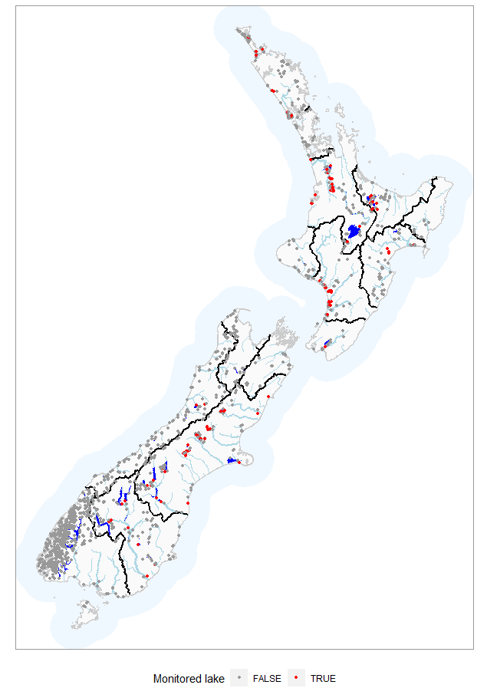

Figure 2. Map of the modelled lakes including the 122 lakes that have adequate monitoring data.

## Current state: monitored lakes

Data describing observations of the four indicators (concentrations of TN, TP, and phytoplankton and Secchi depth) for monitored lakes are available from LAWA[1]. For lakes with sufficient data, the Scenario Builder for Lakes WebApp derives the ‘current’ value of each lake and indicator combination from the monitoring observations. Median values of each indicator were obtained for the five-year period ending 2022 for which at least 45 observations are available (75% of the monthly sampling intervals in a five-year period). WebApp applies these filtering rules to ensure a reasonable number of observations are included and the dataset is representative of current state. This resulted in 122 lakes for which measured current state (i.e., derived from the monitoring data covering the five-year period) was available.

The user should be aware that the attribute grade (i.e., A, B, C or D) shown by the WebApp will sometimes differ from attribute grades displayed on the LAWA website for two reasons. First, the data available on LAWA may correspond to a different time period than the five years ending 2022. Second, for the phytoplankton attribute, the WebbApp grade is based on only the median value, whereas the LAWA grade is based on both statistics.

## Current state: unmonitored lakes

For all lakes, the current state of four indicators (TN, TP, phytoplankton, Secchi) has been estimated by Snelder et al. (2023). These predictions were made by combining observations of the indicators for between 55 to 124 lakes, depending on the indicator, from regional council state-of-the-environment monitoring programmes, for the period 2016 to 2020. The median values of each indicator for each lake were calculated and were then fitted to predictor variables describing the lakes and their catchments using random forest regression models. The performance of these models assessed using the coefficient of determination based on the observations and independent predictions was 0.78, 0.62, 0.45 and 0.64 for TN, TP, phytoplankton, Secchi, respectively (Snelder et al., 2023). This indicates that the absolute values of the model predictions are uncertain at the lake-scale and where lakes have measured indicators, these are used by the WebbApp. However, for lakes without measured indicators, the predicted values are indicative. In addition, there can be more confidence in the WebbApp’s estimation of the relative change associated with a modelled scenario than the absolute values.

## Reference state

Estimates of the four indicators (TN, TP, phytoplankton, Secchi) for lakes under reference conditions are derived from models. Predictions are made by coupling estimates of reference state input loads of TN and TP (tonnes/year) to lakes with the models of Abell et al. (2018). Estimates of reference state TN and TP loads are described in detail in Appendix B and the models of Abell et al. (2018) are described in detail in Appendix C.

Briefly, reference state TN and TP loads were estimated in two steps. First, estimates were made of the reference mean concentration of segments of the digital river network that discharge into lake. These were derived using the method of Dodds and Welch (2000), which was later modified by McDowell et al. (2013). The method used observations of mean TN and TP at ~800 river monitoring sites across New Zealand. The observations were regressed against an indicator of anthropogenic pressure defined by the density of pastoral animals in the upstream catchment. Separate regression parameters were estimated for 14 river classes defined by the River Environment Classification (REC: Snelder and Biggs, 2000), which allowed the model to account for natural variation in climate and topography. The estimate of reference mean concentration was provided by the intercept parameters of the model, which were defined for each REC class. At the second step, the load for each lake was derived as the sum of the estimated reference mean concentration multiplied by the mean flow for each segment of the digital river network discharging into each of the modelled lakes.

The models of Abell et al. (2018) are based on the work of Vollenweider (1976) who showed that in-lake concentrations could be estimated as a function of the loading rate dived by the lake surface area (e.g., mg TN m-2 year-1), lake mean depth (m) and water residence time (year-1). Abell et al. (2018) used this approach to fit models to a set of monitored New Zealand lakes. Those models express in-lake concentration of TN, TP, phytoplankton and Secchi depth as a function of the incoming annual TN and TP loads and several descriptors of the lake including depth, windspeed and water residence time. The estimated reference TN and TP loads were used as inputs to the Abell et al. (2018) models to estimate the reference in-lake state for TN, TP, phytoplankton, and Secchi depth.

## Modelling catchment management scenarios

To predict the impact of catchment land use or mitigation scenarios on lake water quality, the WebApp models the loss of nutrients from land to a river segment, as described in the following subsections.

### Nutrient loss rates

The loss of nutrients from land is quantified by diffuse source nutrient loss rates. The WebApp uses diffuse source nutrient loss rates (expressed as export coefficients in kg ha-1 yr-1) that were primarily sourced from Srinivasan et al. (2021). Srinivasan et al. (2021) derived a land use typology and associated diffuse source loss rates, which provide nearly complete coverage of New Zealand (all land is assigned to a land use type and a diffuse source loss rate for TN and TP, except for land with a cover type of ‘urban’ or ‘bare’). Land use types comprise a combination of three factors, land use, slope and moisture, each of which is expressed as a category. Land use was defined by combining the national land cover database (LCDB, version 5) with spatial data describing the distribution of Sheep & Beef and Dairy land use[2], based on data obtained from Monaghan et al. (2021). Spatial layers describing the distribution of the Srinivasan et al. (2021) slope and moisture categories were derived based on the descriptions provided in Srinivasan et al. (2021). These were based on slope from the Land Resource Inventory (Newsome et al*.* 2008), mean annual rainfall data provided by Ministry for the Environment[3] and mapped irrigation data obtained from the Ministry for the Environment[4].

Srinivasan et al. (2021) derived loss rates for the land use types representing pastoral agriculture based on application of the OVERSEER® nutrient budgeting model for a sample of farms that belonged to each type. Loss rates for Arable, Cropping, Forestry and Native Bush were also taken from Srinivasan et al. (2021).

For the urban land cover category, TN and TP loss rates for the Scenario Builder for Rivers WebApp were obtained from Moores et al. (2017). Because the remaining land use categories represented bare ground, wetlands, lakes and rivers, which generally have small areal contributions and no estimates were available, TN and TP losses were set to zero. The complete list of land use types and their associated loss rates that were used in the calculations made by the WebApp is shown in Table A1 in Appendix A and are referred to hereafter as the Srinivasan et al. (2021) types.

### Assigning nutrient loss rates to land areas

To assign all land in the catchments of the monitoring sites to a type and an associated loss rate, the LCDB spatial layer was reclassified into the land use categories defined by Srinivasan et al. (2021). That reclassification is shown Table A2 in Appendix A.

The WebApp tabulates the proportion of the catchment area in each land use type but does not display the spatial distribution of the land use types. The WebApp simplifies the description of land use in the catchment of each individual site by aggregating the Srinivasan et al. (2021) types to the eight categories shown in Table 2, but the underlying calculations use the detailed types (as in Srinivasan et al., 2021) and their associated loss rates. When the WebApp is used to simulate land use change the calculations are performed using loss rates for the eight categories shown in Table 2, which are calculated as:

Equation 1

where is the calculated loss rate for the jth (of 8) land use category shown in Table 2 and and are the area and loss rates for the ith (of 36) underlying Srinivasan et al. (2021) land use type.

**Table 2: Simplification of the detailed land use categories, defined primarily by Srinivasan et al. (2021), into the land use categories displayed by the Scenario Builder for Rivers WebApp.**

|  |  |
| --- | --- |
| **Simple land use category displayed by the WebApp** | **Underlying detailed categories** |
| Sheep & Beef | Sheep & Beef land use defined and mapped by Monaghan et al. (2021) combined with the slope and moisture categories defined by Srinivasan et al. (2021). |
| Dairy | Dairy defined and mapped by Monaghan et al. (2021) combined with the slope and moisture categories defined by Srinivasan et al. (2021). |
| Forestry | Forestry defined by Srinivasan et al. (2021) and mapped from LCDB v5 as shown in Table A2 (Appendix A). |
| Short-rotation Crop | All short-rotation Cropland mapped from LCDB v5 assumed to be Arable, as defined by Srinivasan et al. (2021). |
| Perennial Crop | Orchard, Vineyard or Other Perennial Crop mapped from LCDB v5 and Viticulture as defined by Srinivasan et al. (2021). |
| Native Vegetation | Native Bush defined by Srinivasan et al. (2021) and mapped from LCDB v5 as shown in Table A2. |
| Other | LCDB v5 categories: Estuarine Open Water, Mangrove, Gravel or Rock, Sand or Gravel, Lake or Pond, River, Not land. |
| Urban | Urban defined by Srinivasan et al. (2021) and mapped from LCDB v5 as Built-up Area (settlement). |

### Default mitigation effectiveness for nutrients

The Scenario Builder for Rivers WebApp provides ‘default’ nitrogen and phosphorus mitigation effectiveness values (%), representing a potential degree of reduction in the losses of nitrogen and phosphorus from land resulting from mitigation actions. These values may be used or replaced with user-defined values of mitigation effectiveness. It is important to note that the default values provided in the WebApp do not include considerations of the feasibility or achievability of the default mitigation effectiveness in the context of an individual catchment; in particular, the WebApp does not include consideration of the existing level of mitigation / remediation actions already undertaken in the catchment. In a catchment where many mitigation actions have already been undertaken, the potential for further improvements by mitigation may be less than the WebApp’s default values. In all cases, regardless of whether the default or user-defined values are used, users are strongly encouraged to satisfy themselves that their land mitigation inputs are realistic for the catchment.

The default nitrogen and phosphorus mitigation effectiveness values for pastoral agriculture categories (Sheep & Beef, Dairy) were informed by Monaghan et al. (2021) and McDowell et al. (2021). Monaghan et al. (2021) defined a system of land use types that differs to that of Srinivasan et al. (2021) but is associated with nitrogen and phosphorus mitigation effectiveness values resulting from mitigation actions that can be applied to pastoral agriculture (Sheep & Beef, Dairy). The default mitigation effectiveness in nitrogen and phosphorus loss rates from each Sheep & Beef and Dairy type were calculated as the relative reduction in loss rates between 2015 and 2035 as defined by Monaghan et al. (2021) and McDowell et al. (2021).

The WebApp simplifies the different Sheep & Beef and Dairy types defined by Monaghan et al. (2021) in the catchments of each individual river site by aggregating them into two categories (i.e., Sheep & Beef and Dairy). The aggregation means that when the WebApp is used to simulate land mitigations, the underlying calculations are based on the detailed mitigation effectiveness values of Monaghan et al. (2021) but the WebApp displays aggregate mitigation effectiveness values for the two pastoral land use categories. The displayed default values are calculated as:

**Equation 2**

where is the aggregate mitigation effectiveness value (%) for the two pastoral agriculture categories (Sheep & Beef, Dairy), and and are the area and mitigation effectiveness values for one of the *p* underlying Monaghan et al. (2021) types.

For non-pastoral land uses, mitigation effectiveness values were either sourced from literature, set at an arbitrary level, or set at zero (for native vegetation, urban and other) (Table 3).

Table 3: Default mitigation effectiveness values for each simplified non-pastoral land use category in the Scenario Builder for Rivers WebApp.

|  |  |  |  |
| --- | --- | --- | --- |
| **Simple land use category displayed by the WebApp** | **Default mitigation effectiveness (%)** | | **Source / comment** |
| N | P |
| Forestry | 0 | 30 | No mitigation expected for nitrogen.  Edwards and Williard (2010) cite 30-60% reduction in P losses from a range of best management practices. 30% selected as the low end of the range given the unknown applicability to NZ context. |
| Short-rotation Crop | 30 | 50 | N: mid-point of values reported in Auckland Council (2021)  P: unknown, inferred from potential sediment reductions (Barber, 2014) |
| Perennial crop | 15 | 50 |  |
| Native Vegetation | 0 | 0 | No mitigation expected |
| Other | 0 | 0 | No mitigation expected |
| Urban | 0 | 0 | Unknown / undocumented N and P mitigation options |

### Estimating total current nutrient loss

The current total nitrogen and total phosphorus loss rates in the catchment of a monitoring site are calculated as the sum of the products of land use category areas and loss rates as shown by Equation 3:

**Equation 3**

Where is a mass per unit time (kg/year), is the area of the *j*th land use category, and is the current loss rate of the *j*th land use category.

The contribution of each land use category to the at each monitoring site is calculated as:

**Equation 4**

where is the contribution of the *j*th land use category to the (%) of total nitrogen or total phosphorus.

### Estimating the total scenario nutrient loss

For a scenario in which mitigation of current total nitrogen or phosphorus loss from one or more land use categories in the catchment of a monitoring site occurs, the total scenario loss rate is calculated as:

**Equation 5**

where is the catchment loss of total nitrogen or total phosphorus as a mass per unit time (kg/year) under the prescribed mitigation scenario and is the assumed reduction in loss rate for the *j*th land use category under the mitigation scenario.

For a scenario that specifies mitigation of nitrogen or phosphorus loss from one or more land use categories, and the proportional area of two or more of the land use categories is changed from the current proportional area, the total scenario loss is calculated by Equation 5 with the proportional areas of the relevant land use categories changed to that assumed by the scenario.

### Predicting scenario indicator values for lakes

The scenario values for each lake indicator are predicted by applying factor reductions that are derived from the changes in catchment TN and TP losses to the current indicators. For lakes that are monitored, the current values are derived from the monitoring data and where lakes are unmonitored, the current values are those predicted by Snelder et al. (2022; see Section 2.3). For each indicator, the factor reductions are based on the models of Abell et al. (2018) and are detailed in Appendix C.

# Examples of outputs for selected scenarios

## Scenarios

To provide some insight into the results of simulations of mitigation and land use changes that can be performed using the Scenario Builder WebApp, a series of three scenarios were simulated for all 1249 modelled lakes (Figure 2). The outputs are reported below for nutrients (TN and TP), as reductions from the current concentration (%) and for nutrients, phytoplankton (as chlorophyll) and Secchi depth as absolute concentrations (mg/L or m). The three scenarios were applied to the catchments of all lakes as follows:

1. apply the Scenario Builder WebApp’s default mitigation effectiveness values for Sheep & Beef and Dairy land
2. Scenario 1 plus convert half of all Sheep & Beef land to Forestry
3. Scenario 1 plus convert one quarter of both Sheep & Beef and Dairy land to Native Vegetation

For all lakes and scenarios described below, the predicted values of the current state of the four indicators were used for consistency. The results of these simulations will differ for monitored lakes when the measured values of the four indicators are used.

## Nutrients

Figure 3 shows the results for all three scenarios as reductions of TN and TP (from the predicted in-lake current concentrations) plotted against the proportion of the catchment occupied by pastoral land use (i.e., Sheep & Beef or Dairy). For Scenario 1, the reduction from current TN and TP increases with increasing proportion of the catchment occupied by pastoral land use to reach an approximate mean reduction of around 30% for catchments having high occupancy by pastoral land use. There is considerable between-site variation in percentage reduction that is achievable under Scenario 1, which reflects two factors. First, the composition of catchments in terms of the area of Sheep & Beef and Dairy is variable. Because the default mitigation effectiveness values are generally higher for Dairy than for Sheep & Beef, all other things being equal, catchments with a greater proportion of Dairy land will have greater reductions. Second, Monaghan et al. (2021) described significant variation in the mitigation reduction rates that can be achieved for their Sheep & Beef and Dairy types. Catchments comprise different combinations of these Monaghan et al. (2021) types and therefore the default mitigation effectiveness values vary significantly between sites.

Figure 3 shows that Scenario 2 generally achieves greater reductions than Scenario 1 and reductions for Scenario 3 exceed those of Scenario 2. In addition, the reductions achieved under Scenarios 2 and 3 increase with increasing proportion of the catchment occupied by pastoral land use. This is to be expected because Scenarios 2 and 3 involve changing fixed proportions of current pastoral land use to Forestry and Native Vegetation, respectively, and therefore the reductions increase with the amount of current pastoral land use. Figure 3 shows that although there are generally larger reductions for Scenario 3 compared to Scenario 2, there is considerable variation and for some sites this pattern is reversed. This is because different catchments comprise different amounts of Sheep & Beef and Dairy and different combinations of the underlying sub-categories and therefore the mitigation reduction rates vary.

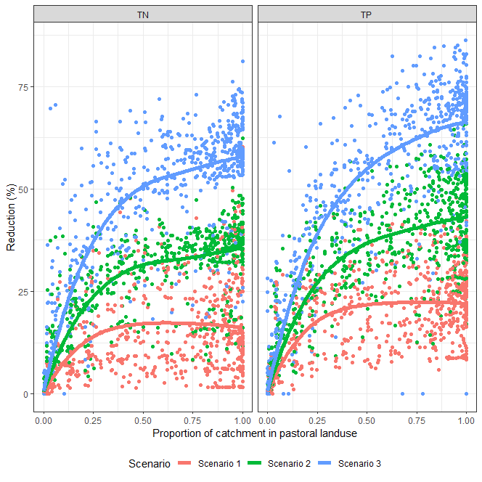

Figure 3. Outputs of the simulations of changes in nutrient concentrations and loads for the three scenarios applied to Sheep & Beef and Dairy land. The plots show the predicted reductions for TN and TP concentrations in all lakes against proportion of the catchment in pastoral land use. The solid lines are smoothed representations of the mean response (i.e., reduction) versus proportion of the catchment in pastoral land use.

Figure 4 shows maps of the lakes coloured by the predicted TN and TP reductions under the three scenarios. These maps indicate geographic variation in the extent to which mitigation is predicted to reduce TN and TP. For example, for Scenario 1, the reductions in TN are generally greater in the Waikato, Manawatu-Whanganui, Taranaki, Canterbury and Southland regions. This is partly because catchments in these regions generally have higher proportions of Dairy land, compared to Sheep & Beef, and a greater proportion of TN is able to be mitigated for Dairy compared to Sheep & Beef land use.

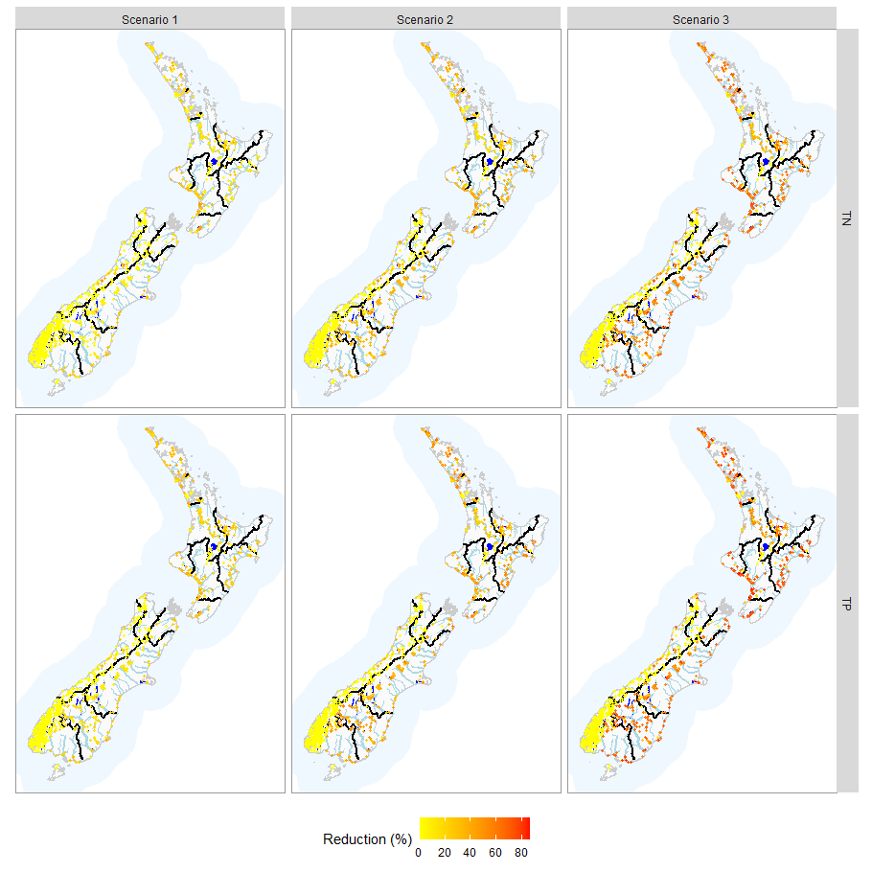

Figure 4. Maps showing outputs of the simulations of the three scenarios applied to Sheep & Beef and Dairy land. The maps show lakes coloured by the predicted reductions for TN and TP.

Figure 5 compares current and predicted concentrations of TN TP, chlorophyll and Secchi depth for the three scenarios. This plot indicates that there are some lakes that have very little or no change in the four indicators under the scenarios. This occurs when lakes have little or no pastoral land use in their catchments. The plot also indicates that the change in absolute values of the indicators generally increases from Scenario 1 to Scenario 3.

To increase the interpretability of these changes in absolute concentrations, the chlorophyll concentrations have been transformed into estimates of NOF grades for the Phytoplankton attribute, which are shown in Figure 6. The plot indicates that improvements in Phytoplankton NOF grades increase from Scenario 1 to Scenario 3, which is consistent with the increasing reductions in concentrations produced by the scenarios. In addition, the plot indicates that, the scenarios rarely produce a change of more than one grade and in many cases do not produce a change in grade. It is noted that even under Scenario 3, a proportion of lakes (0.9%) are not lifted out of the D band (of 8.3% that are currently estimated to be in the D band). This indicates that for some lakes, even relatively drastic actions will not achieve minimum acceptable states (i.e., C band or better).

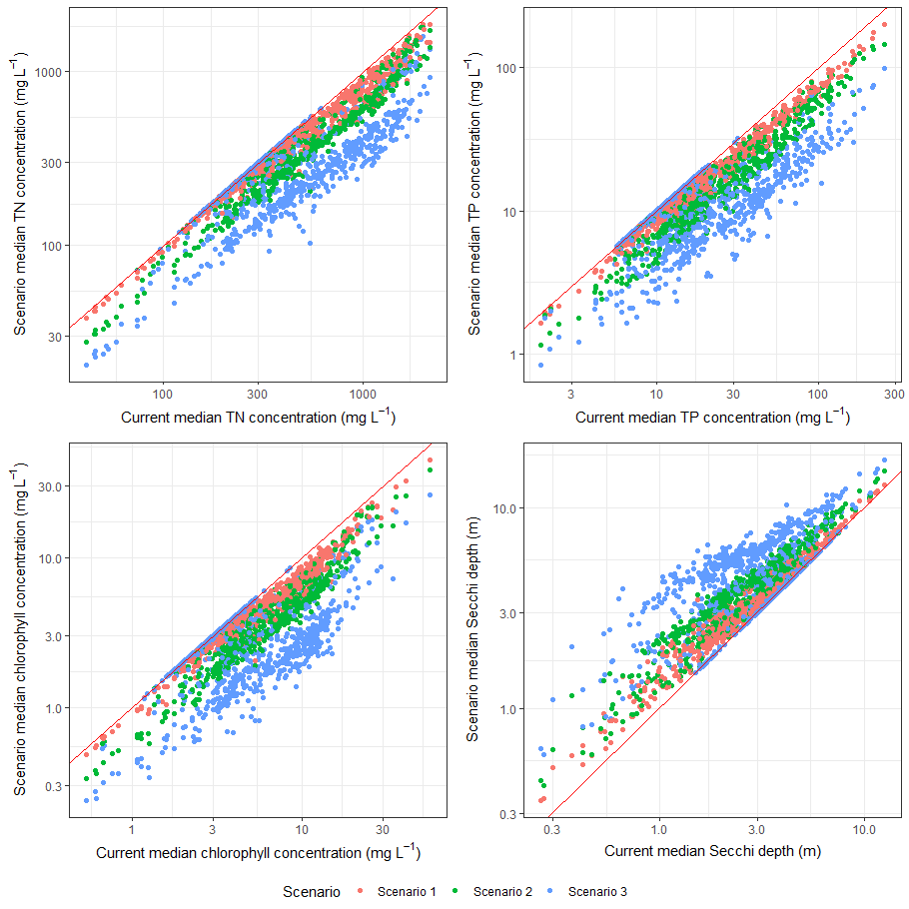

Figure 5. Comparison between current and predicted concentrations of TN, TP, chlorophyll and Secchi depth for the three scenarios. The red solid line is one to one. Lake and scenario combinations lying on this line are predicted to have no change in the indicator under the scenario.

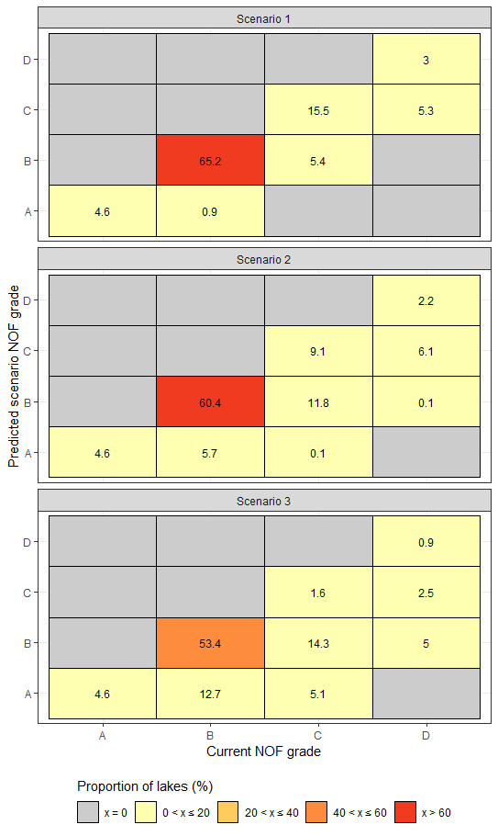

Figure 6. Changes in current concentrations chlorophyll under the three scenarios expressed as NOF Phytoplankton attribute grades. Each panel represents a matrix indicating the proportion of lakes (%) that have current and predicted NOF periphyton grades as indicated by the x and y axes, respectively.

# User Guide

This section provides step-by-step instructions on how to use the Freshwater Improvement Scenario Builder for Lakes web application.

## Using the WebApp to explore water quality current state

## Using the WebApp to assess catchment scenarios

This subsection contains instructions on how to use the Scenario Builder for Lakes WebApp to predict how a catchment scenario that consist of land mitigation and/or land use change will impact the current state median of a selected indicator. Note that before carrying out a scenario assessment, the steps in a ‘Current state’ analysis (Section 4.1) must be carried out, i.e., a lake and a measured indicator must be selected.

### Land mitigation scenario

### Land use change scenario

### Exporting the results

The Scenario Builder for Lakes WebApp results can be exported in PDF format. This can only be done once a scenario has been run. The button ‘Download pdf report’ will appear blue once a scenario has been run.

Note: the PDF report will be based on the most recent scenario run by the user. Only one scenario will be included in the report.

## Example

The box below contains an example of how to use the Scenario Builder for Lakes WebApp. Note that the mitigation and land use change scenarios in the example are purely hypothetical and were devised for the purpose of illustrating the WebApp functions.

## Troubleshooting

To report any problems using the Scenario Builder for Lakes WebApp, please get in touch using the Contact form on the Monitoring Freshwater Improvements website.

# Acknowledgements

# References

Abell J, van Dam-Bates P (2018) Modelling Reference and Current Trophic Level Index for New Zealand Lakes. Ecofish Research Ltd Hamilton, New Zealand.

Abell JM, Özkundakci D, Hamilton DP, van Dam-Bates P, Mcdowell RW (2019) ‘Quantifying the Extent of Anthropogenic Eutrophication of Lakes at a National Scale in New Zealand’ Environmental science & technology 53, 9439–9452.

Abell J, Özkundakci D, McBride CG, Allan MG (In prep) Estimating nutrient load targets for lakes at a regional scale.

Booker DJ, Woods RA (2014) ‘Comparing and combining physically-based and empirically-based approaches for estimating the hydrology of ungauged catchments’ Journal of Hydrology 508, 227–239. doi:10.1016/j.jhydrol.2013.11.007

Fraser C (2024) Assessment of Nutrient Load Reductions Required to Achieve Target Attribute States in the Rivers, Lakes and Estuaries of the Canterbury Region. LWP Client Report 2024–07. LWP Ltd, Christchurch, New Zealand.

Leathwick J, West D, Chadderton L, Gerbeaux P, Kelly D, Robertson H, Brown D (2010) Freshwater Ecosystems of New Zealand (FENZ) Geodatabase: Version one user guide. Department of Conservation, Hamilton, New Zealand.

Snelder T, Smith H, Plew D, Fraser C (2023) Nitrogen, phosphorus, sediment and Escherichia coli in New Zealand’s aquatic receiving environments: Comparison of current state to national bottom lines. LWP Client Report 2023–06. LWP Ltd, Christchurch, New Zealand.

Srinivasan MS, Muirhead RW, Singh SK, Monaghan RM, Stenger R, Close ME, Manderson A, Drewry JJ, Smith LC, Selbie D (2021) ‘Development of a national-scale framework to characterise transfers of N, P and Escherichia coli from land to water’ New Zealand Journal of Agricultural Research 64, 286–313.

Whitehead A, Fraser CE, Snelder T, White R (2021) Water quality state and trends in New Zealand lakes. Analyses of national lakes data ending in 2020. 2021297CH. NIWA,

Previous references, to be checked if still present:

Auckland Council 2021. Freshwater management tool: report 6. Literature review of primary sector responses to water quality: efficacy and cost. FWMT report, 2021/6. Prepared by Perrin Ag Consultants for Auckland Council.

Barber A. 2014. Erosion and sediment control guidelines for vegetable production. A report for Horticulture New Zealand.

Edwards PJ, Williard KWJ. 2010. Management Practices for Reducing Sediment and Nutrient Losses in the Eastern United States. *Journal of Forestry,* July/August 2010.

McDowell RW, Snelder TH, Cox N, Booker DJ, Wilcock RJ. 2013. Establishment of reference or baseline conditions of chemical indicators in New Zealand streams and rivers relative to present conditions. *Marine and Freshwater Research 64*: 387–400.

McDowell RW, Monaghan RM, Smith C, Manderson A, Basher L, Burger DF, Laurenson S, Pletnyakov P, Spiekermann R, Depree C. 2020. Quantifying contaminant losses to water from pastoral land uses in New Zealand III. What could be achieved by 2035? *New Zealand Journal of Agricultural Research 64*(3):390–410*.* https://doi.org/10.1080/00288233.2020.1844763

Monaghan R, Manderson A, Basher L, Smith C, Burger D, Meenken E, McDowell R. 2021. Quantifying contaminant losses to water from pastoral landuses in New Zealand I. Development of a spatial framework for assessing losses at a farm scale. *New Zealand Journal of Agricultural Research* *64*(3): 344–364. https://doi.org/10.1080/00288233.2021.1936572

Moores J, Easton S, Gadd J, Sands M. 2017. Te Awarua-o-Porirua Collaborative Modelling Project: Customisation of urban contaminant load model and estimation of contaminant loads from sources excluded from the core models. Report prepared for Greater Wellington Regional Council. NIWA Client report 2017050AK.

Newsome PFJ, Wilde RH, Willoughby EJ 2008. Land resource information system spatial data layers: Data dictionary. Palmerston North, Manaaki Whenua – Landcare Research. 75 p

Snelder TH, Biggs BJF. 2002. Multi-scale river environment classification for water resources management. *Journal of the American Water Resources Association 38*: 1225–1240. https://doi.org/10.1111/j.1752-1688.2002.tb04344.x

Snelder T, Cox T, Fraser C, Kerr T, Elliot S. 2023. Quantifying Catchment Nutrient Modelling Parameters. An analysis using the available New Zealand data. LWP Client Report 2023–03. LWP Ltd, Christchurch, New Zealand.

Snelder T, Elliot S, Muirhead R, Fraser C. 2024. Parameters for simple empirical catchment water quality models for simulating *Escherichia coli* in New Zealand rivers. LWP Ltd, Christchurch, New Zealand. Retrievable from https://www.monitoringfreshwater.co.nz/research.

Snelder T, Kilroy C. 2023. Revised Nutrient Criteria for Periphyton Biomass Objectives. Updating criteria referred to in Ministry for Environment 2022 guidance. LWP Client Report 2023–08. LWP Ltd, Christchurch, New Zealand.

Snelder TH, Whitehead AL, Fraser C, Larned ST, Schallenberg M. 2020. Nitrogen loads to New Zealand aquatic receiving environments: comparison with regulatory criteria. *New Zealand Journal of Marine and Freshwater Research 54*: 527–550.

Srinivasan MS, Muirhead RW, Singh SK, Monaghan RM, Stenger R, Close ME, Manderson A, Drewry JJ, Smith LC, Selbie D, Hodson R. 2021. Development of a national-scale framework to characterise transfers of N, P and Escherichia coli from land to water*. New Zealand Journal of Agricultural Research* *64*(3): 286–313. https://doi.org/10.1080/00288233.2020.1713822

Whitehead A, Fraser CE, Snelder TH, Walter K, Woodward S, Zammit C. 2021. Water quality state and trends in New Zealand Rivers. Analyses of national data ending in 2020. 2021296CH. NIWA, Christchurch.

# Appendix A: Land use types and loss rates

Table A1: Complete list of land use types and their associated loss rates (kg/ha/year) used in the Scenario Builder for Rivers WebApp.

| **Land Use** | **Slope** | **Moisture** | **Type** | **TN Loss Rate** | **TP Loss Rate** |
| --- | --- | --- | --- | --- | --- |
| Dairy | Flat | Dry | Dairy-Flat-Dry | 29.5 | 0.85 |
| Dairy | Flat | Moist | Dairy-Flat-Moist | 39 | 1.05 |
| Dairy | Flat | Wet | Dairy-Flat-Wet | 48.5 | 1.25 |
| Dairy | Flat | Irrigated | Dairy-Flat-Irrigated | 55.5 | 0.95 |
| Dairy | Rolling | Dry | Dairy-Rolling-Dry | 27 | 1 |
| Dairy | Rolling | Moist | Dairy-Rolling-Moist | 32 | 1.5 |
| Dairy | Rolling | Wet | Dairy-Rolling-Wet | 45 | 1.8 |
| Dairy | Rolling | Irrigated | Dairy-Rolling-Irrigated | 52 | 1.3 |
| Dairy | Easy Hill | Dry | Dairy-Easy Hill-Dry | 28 | 1 |
| Dairy | Easy Hill | Moist | Dairy-Easy Hill-Moist | 32 | 1.5 |
| Dairy | Easy Hill | Wet | Dairy-Easy Hill-Wet | 45 | 1.8 |
| Dairy | Easy Hill | Irrigated | Dairy-Easy Hill-Irrigated | 52 | 1.3 |
| Dairy | Steep | Moist | Dairy-Steep-Moist | 32 | 1.5 |
| Dairy | Steep | Wet | Dairy-Steep-Wet | 45 | 1.8 |
| Dairy | Steep | Irrigated | Dairy-Steep-Irrigated | 52 | 1.3 |
| Sheep and Beef | Flat | Dry | Sheep and Beef-Flat-Dry | 7 | 0.4 |
| Sheep and Beef | Flat | Moist | Sheep and Beef-Flat-Moist | 18 | 0.6 |
| Sheep and Beef | Flat | Wet | Sheep and Beef-Flat-Wet | 24 | 0.75 |
| Sheep and Beef | Flat | Irrigated | Sheep and Beef-Flat-Irrigated | 20 | 0.6 |
| Sheep and Beef | Rolling | Dry | Sheep and Beef-Rolling-Dry | 7.5 | 0.35 |
| Sheep and Beef | Rolling | Moist | Sheep and Beef-Rolling-Moist | 11.5 | 0.7 |
| Sheep and Beef | Rolling | Wet | Sheep and Beef-Rolling-Wet | 17.5 | 0.8 |
| Sheep and Beef | Rolling | Irrigated | Sheep and Beef-Rolling-Irrigated | 11.5 | 0.7 |
| Sheep and Beef | Easy Hill | Dry | Sheep and Beef-Easy Hill-Dry | 5 | 0.5 |
| Sheep and Beef | Easy Hill | Moist | Sheep and Beef-Easy Hill-Moist | 8.5 | 1 |
| Sheep and Beef | Easy Hill | Wet | Sheep and Beef-Easy Hill-Wet | 9 | 1.6 |
| Sheep and Beef | Easy Hill | Irrigated | Sheep and Beef-Easy Hill-Irrigated | 8.5 | 1 |
| Sheep and Beef | Steep | Dry | Sheep and Beef-Steep-Dry | 4.5 | 0.6 |
| Sheep and Beef | Steep | Moist | Sheep and Beef-Steep-Moist | 6 | 1.6 |
| Sheep and Beef | Steep | Wet | Sheep and Beef-Steep-Wet | 6.5 | 2.8 |
| Sheep and Beef | Steep | Irrigated | Sheep and Beef-Steep-Irrigated | 6 | 1.6 |
| Arable | All | All | All | 13.5 | 0.1 |
| Vegetable* | All | All | All | 72 | 1.9 |
| Viticulture | All | All | All | 10 | 0.2 |
| Forestry | All | All | All | 4 | 0.4 |
| Native Bush | All | All | All | 2 | 0.3 |
| Urban | All | All | All | 11 | 1 |

*Vegetable class is not represented in the WebApp. Refer to Section 2.6.

Table A2: Re-classification of LCDBV5 Name_2018 classes to Srinivasan et al. (2021) land use classes.

|  |  |  |
| --- | --- | --- |
| **LCDBV5 Name_2018** | **Class_2018** | **Reclass** |
| Indigenous Forest | 69 | Native Vegetation |
| Deciduous Hardwoods | 68 | Native Vegetation |
| Low Producing Grassland | 41 | Pasture |
| Manuka and/or Kanuka | 52 | Native Vegetation |
| Exotic Forest | 71 | Forestry |
| Built-up Area (settlement) | 1 | Urban |
| Forest – Harvested | 64 | Forestry |
| Broadleaved Indigenous Hardwoods | 54 | Native Vegetation |
| Gravel or Rock | 16 | Native Vegetation |
| Lake or Pond | 20 | Native Vegetation |
| Gorse and/or Broom | 51 | Native Vegetation |
| High Producing Exotic Grassland | 40 | Pasture |
| Landslide | 12 | Native Vegetation |
| Mixed Exotic Shrubland | 56 | Forestry |
| Orchard, Vineyard or Other Perennial Crop | 33 | Viticulture |
| Short-rotation Cropland | 30 | Arable |
| Sand or Gravel | 10 | Native Vegetation |
| Herbaceous Freshwater Vegetation | 45 | Native Vegetation |
| River | 21 | Native Vegetation |
| Surface Mine or Dump | 6 | Urban |
| Urban Parkland/Open Space | 2 | Native Vegetation |
| Transport Infrastructure | 5 | Urban |
| Flaxland | 47 | Native Vegetation |
| Estuarine Open Water | 22 | Native Vegetation |
| Fernland | 50 | Native Vegetation |
| Sub Alpine Shrubland | 55 | Native Vegetation |
| Tall Tussock Grassland | 43 | Native Vegetation |
| Herbaceous Saline Vegetation | 45 | Native Vegetation |
| Matagouri or Grey Scrub | 58 | Native Vegetation |
| Alpine Grass/Herbfield | 15 | Native Vegetation |

# Appendix B: Estimated reference loads

Reference loads of TN and TP loads were estimated in two steps. First, estimates were made of the reference mean concentration of segments of the digital river network that discharge into each lake. These estimates were derived from monthly monitoring observations at 932 and 895 state of environment monitoring sites distributed across New Zealand. The mean value of the monthly observations at these sites were calculated for the five-year period between 2016 and 2020 provided the site and variable met the filtering rules described by Whitehead et al. (2022). A period of five years represented a reasonable trade-off because it yielded a sample size that met the filtering rules for many sites and variable combinations but was a sufficiently short and recent time period to not be greatly affected by trends. The five-year period is consistent with the period duration used in previous national water-quality state analyses (e.g., Larned et al., 2018).

Each site was assigned to the REC Source-of-flow class associated with the segment of the digital river network on which it was located. Because some Source-of-flow classes were represented by few monitoring sites, we collapsed some classes into more commonly monitored classes that were environmentally adjacent to derive ‘modified Source-of-flow’ classes. This resulted in 14 modified Source-of-flow’ classes compared to the 21 that a defined by the REC.

We also obtained the density of pastoral animals in the catchment upstream of each monitoring site as a measure of anthropogenic pressure at each monitoring sites. The numbers of animals in the four stock type categories are periodically surveyed on all livestock farms by Statistics New Zealand as part of the agricultural production census (APC). We used the highest resolution versions of APC data that are publicly available, which are associated with a spatial coverage comprising 960 hexagonal grid cells (35,000 ha) that cover all New Zealand (https://statisticsnz.shinyapps.io/livestock_numbers/). For each grid cell, the numbers of animals in each stock type category were obtained for the 2017 (most recent available) census year.

The animal densities were converted to stock unit equivalents to provide a measure of land use intensity that is comparable across the different stock types (Di and Cameron 2002). A stock unit equivalent (SU) is a commonly used measure of metabolic demand by livestock in New Zealand (Parker 1998). The density of animals of each type in each catchment were converted to stocking intensity (SU ha-1) by multiplying by their SU equivalent as described by Snelder et al. (2021).

We used analysis of covariance (ANCOVA) to model the mean values of TN and TP. Our method was based on previous applications of ANCOVA to estimate natural concentrations of various water quality variables in rivers (Dodds and Oakes 2004; McDowell et al. 2013) and to estimate natural yields of nutrients in New Zealand’s rivers (Snelder et al., 2018). In the current study, ANCOVA was used to fit linear relations between the response variables (i.e. mean values TN and TP), stocking intensity as a continuous predictor that represented anthropogenic pressure associated with land use intensity, and River Environment Classification (REC) classes that represented climate and topography. The categorical predictors (REC classes) allowed the relation between the response and the continuous variable to differ by environmental class. The intercept terms of the models (i.e., the mean concentration when stocking intensity is zero) represent the estimated reference condition and were therefore the output from the model of greatest interest.

We log (base 10) transformed the response variables (i.e., site mean TN and TP) to an approximately normal distribution to improve model performance. We also inspected scatter plots of the mean concentrations against the continuous predictor (stocking intensity) for evidence of non-linear relationships. Standard forward and backward stepwise linear regression were applied to the saturated ANCOVA models to identify the most parsimonious models. In this procedure, the Akaike information criterion (Akaike, 1973) was used to apply a penalised log-likelihood method to evaluate the trade-off between the degrees of freedom and fit of the model as predictor variables were added or removed (Crawley, 2002). Model performance was assessed using the coefficient of determination (i.e., *R2* value).

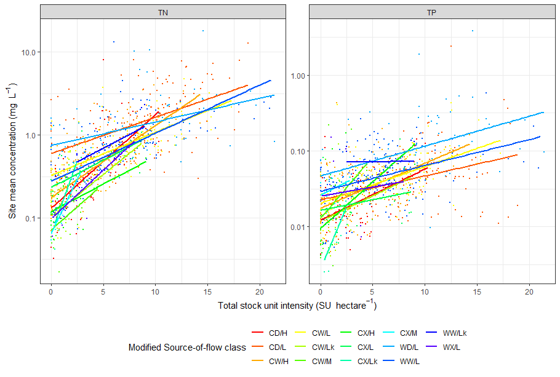

Figure 7. Scatter plots of the mean concentrations of TN and TP against the continuous predictor (stock unit intensity). The lines represent regressions fitted separately for each modified source-of-flow class.

The mean values of TN and TP increased with increasing stocking intensity for all but one modified source-of-flow class (Figure 7). The R2 values for the models were 0.62 and 0.35 for TN and TP, respectively. The estimated reference mean concentrations for each of the modified Source-of-flow classes are shown in Figure 8. The reference mean concentrations were generally higher for lowland Source-of-flow classes than for Hill and Mountain classes.

Figure 8. Estimated reference mean concentrations for TN and TP and each of the 14 modified Source-of-flow classes. The error bars indicate the 95% confidence interval. Note the y-axis is log (base 10) scale to better distinguish differences between the classes.

At the second step, the load for each lake was derived as the sum of the estimated reference mean concentration, derived above, multiplied by the mean flow for each segment of the digital river network discharging into each of the modelled lakes. The mean flows were obtained from NZ River Maps (<https://shiny.niwa.co.nz/nzrivermaps/>) and the mean flow estimates were based on Booker and Woods (2014). We note that the load estimated as mean concentration multiplied by the mean flow can be biased Snelder et al. 2017), but this method is a first order approximation that allowed an estimate of the reference load for each lake to be made.

# Appendix C: Lake models

Predictions of in-lake concentrations of TN, TP, and phytoplankton and Secchi depth are made by coupling input loads with the lake models of Abell and van Dam-Bates (2018) with modifications for some regions. The details of the use of these models depends on whether reference or scenario values of the in-lake variables are being simulated. We describe the details of the models for both types of prediction and the regional modifications below.

## Reference state predictions

The primary input to the models of Abell and van Dam-Bates (2018) is the mean flow weighted concentration of TN and TP (hereafter and ), which should be understood as a mean annual load divided by the mean annual inflow volume. These values are obtained by dividing the estimated annual input loads of TN and TP (see Section 2.4) by the mean annual inflow volume. Annual inflow volume for each lake is obtained from estimates of mean flow made for every segment of the drainage network by Booker and Woods (2014).

By default, for each lake, the in-lake concentration of TN and TP is predicted using the following models:

Equation 1

Equation 2

where *TPlake* and *TNlake* are median concentrations of TN and TP (mg m-3), k1, Δk1, k2, and all β are fitted parameters, τis water residence time (years) derived from the FENZ database (Leathwick et al. 2010), and is the maximum depth of the lake derived from the FENZ database. The variable 𝑑 is a dummy variable that indicates whether a lake is shallow (𝑑 = 0) or deep (𝑑 = 1). The same threshold as (Abell *et al.* 2019) of >7.5m were used to define deep lakes. The coefficients k1, Δk1, and k2 are values of 0, 0.44, and 0.13, respectively. The coefficients , , are 1.6, 0.54 and -0.41, respectively.

Note that when the predictions from these models are back transformed, by raising to the power of 10, the results are multiplied by retransformation bias correction factors of 1.34 (TP) and 1.16 (TN), respectively Abell and van Dam-Bates (2018).

Note that the above two models are the *default*. In the Waikato region, alternative models were used based on recent work by (Abell et al. In prep). For each lake in the Waikato region, the in-lake concentration of TN and TP is predicted as:

Equation 3

where i represents either nutrient TN or TP and *Tilake* is are median in-lake concentrations of (mg m-3), and is the mean flow weighted concentration of TN or TP. The coefficients , are 2.3969 and 0.3564 respectively for the TN model and 0.9217 and 0.6172 respectively for the TP model. As for the default equations, when the Waikato region model predictions are back transformed, by raising to the power of 10, the results are multiplied by retransformation bias correction factors of 1.24 (TN) and 1.34 (TP), respectively.

In the Canterbury region, we used alternative coefficients for Equation 2 that were fitted by (Fraser 2024) . The coefficients k1, Δk1, and k2 for Canterbury are 0.09288, 0.826, and 0.0205, respectively. As for the default equations, when the Canterbury region TP model predictions are back transformed, by raising to the power of 10, the results are multiplied by retransformation bias correction factors of 1.696.

Predictions of in-lake concentrations chlorophyll and lake Secchi depth made by coupling the estimated in-lake concentrations of TN and TP with empirical models of Abell and van Dam-Bates (2018).

For each lake, the in-lake concentration of chlorophyll and lake Secchi depth is predicted using the following default models:

Equation 4

Equation 5[5]

For Equation 4, *TPlake* and *TNlake* are median concentrations of TN and TP (mg m-3) that can be either observed values or predicted values derived using Equation 1 and 2. The coefficients , , in Equation 3 are -1.8, 0.70(TN) and 0.55(TP), respectively (Abell and van Dam-Bates 2018). Note that when the predictions from Equation 3 are back transformed, by raising to the power of 10, the results are multiplied by retransformation bias correction factors of 1.12.

For Equation 5, is the median concentrations of chlorophyll (mg m-3) that can be either observed values or predicted values derived using Equation 4. The variable 𝑑 is a dummy variable that indicates whether a lake is shallow (𝑑 = 0) or deep (𝑑 = 1), where shallow lakes are defined as z*max* ≤ 20 m. The last term of Equation 5 represents resuspension (in shallow lakes). In this term, the variable *Fetch* is the maximum lake fetch (m), and *U* is the mean windspeed (m s-1), based on analysis of regional climate data by Leathwick et al. (2010). Both of these variables are obtained for each lake from the FENZ database. The coefficients , , and in Equation 5 are 3.46 (intercept), -0.74(Chla), -0.79 (Chla x d) and -0.35 (resuspension) (Abell and van Dam-Bates 2018).

## Scenario predictions

When the models of Abell and van Dam-Bates (2018) are used to predict scenario indicator vales (i.e., TN, TP, phytoplankton, Secchi depth) the quantity of interest is the change from the current value of the indicator. A ‘change ratio’ (i.e., scenario value/current value) for each indicator, which we refer to as , was derived by rearranging the Abell and van Dam-Bates (2018) equations in combination with a ratio that expresses the difference between the current and scenario input loads, which we call . The values of for TN and TP are obtained by dividing the total scenario loss by the total current loss (see Sections 2.5.5 and 2.5.4), which assumes that the rate at which the losses are attenuated in the catchment before loads are discharged to lakes are constant for both the current and scenario conditions. The scenario value of the indicators TN, TP and chlorophyll are then calculated as:

Equation 6

Where is the change ratio for an indicator, is the current state of the indicator and is the predicted value of the indicator under the scenario. The symbol *x* in parentheses indicates whether the indicator is total nitrogen (N), total phosphorus (P), chlorophyll (Chla).

By default, for each lake, the change ratio for the in-lake concentration of TP, when is:

Equation 7

where and when the change ratio for the in-lake concentration of TP is:

Equation 8

By default, for each lake, the change ratio for the in-lake concentration of TN is:

Equation 9

For each lake, the change ratio for the in-lake concentration of chlorophyll is:

Equation 10

For each lake, when the in-lake scenario Secchi depth () is predicted from the current Secchi depth () and change in the in-lake concentration of chlorophyll as:

Equation 11

and when the in-lake Secchi depth is:

Equation 12

For lakes in the Waikato region, the change ratio for the in-lake concentration of TP is:

Equation 13

where , and the change ratio for the in-lake concentration of TN is:

Equation 14

For lakes in the Canterbury region, the change ratio for the in-lake concentration of TP is:

Equation 15

Where, when , and when ,

1. Land, Air and Water Aotearoa. [www.lawa.org.nz](http://www.lawa.org.nz) accessed February 2024.
2. Where LCDB specifies high or low producing exotic grassland but Monaghan et al. (2021) has not assigned to Sheep and Beef or Dairy, LCDB ‘low producing grassland’ was assigned as Sheep and Beef and LCDB ‘high producing grassland’ was assigned as Dairy.
3. data.mfe.govt.nz/layer/89421-average-annual-rainfall-19722016
4. https://data.mfe.govt.nz/layer/105407-irrigated-land-area-raw-2020-update/
5. Note that this equation is derived from Model 3Secchi of Abell and van Dam-Bates (2018). However, Equation 4 has the third term of Model 3Secchi removed following the results presented in Table 21 of Abell and van Dam-Bates (2018).